To whom it may concern

The UK Data Protection Act 1998 protects you and the personal data you supply to the University of Edinburgh.

All data kept within the University is treated as confidential. The University maintains student data in secure conditions and processes and discloses data in accordance with the terms of its Data Protection notification. Personal data you supply to the University will be made available for official purposes to academic and administrative staff, but access to data is strictly confined to staff with relevant responsibilities.

Therefore, if you would like your agent to represent you and obtain information from the University of Edinburgh regarding your application for study, you must give the University of Edinburgh your express permission to do so. Please note that should you give permission some data about your application to the University of Edinburgh will be displayed to your agent via a secure website.

Please sign the disclaimer below to give permission:

DISCLAIMER
Full Name of Student | Maryam Ahmed Zamim
Applicant UUN/UCAS ID (not applicable for International Foundation Programme applicants)
Name of Agent (and branch if applicable) | UKuni
I give permission for the University of Edinburgh to pass any information regarding my application and my documents to my agent (stated above)
Signature of student
Date | 8/12/2022

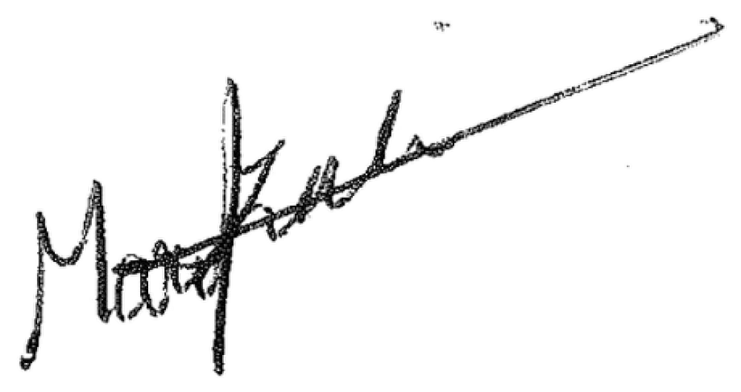
When you register as a student of the University of Edinburgh, you will be asked to sign a further statement of consent for Data Protection purposes. Details on Data Protection can be found at: https://www.ed.ac.uk/data-protection

The Privacy statement for applicants can be found at: https://www.ed.ac.uk/studying/admissions/privacy-statement

Student Recruitment & Admissions
University of Edinburgh, 33 Buccleuch Place, Edinburgh, EH8 9JS, Scotland Email: Representatives@ed.ac.uk Tel: +44 (0)131 650 4296 https://www.ed.ac.uk/student-recruitment

