Architecture integrates the aspects of design elements, building's needs, structural features, and aesthetics. The fact that architecture synthesizes technological, scientific, and artistic fields of study to provide utility, comfort, and beauty has greatly motivated my passion in pursuing it. I aspire to participate in the process of envisioning a structure and turning it into reality. Climate change has inspired my dream of becoming an architect. Since climate change has been attributed to the design problem, I would like to be at the forefront of promoting sustainability by facilitating the construction of buildings that utilize minimum or no fossil fuels. Therefore, I seek opportunities to participate in architectural projects that promote sustainability and accessibility.

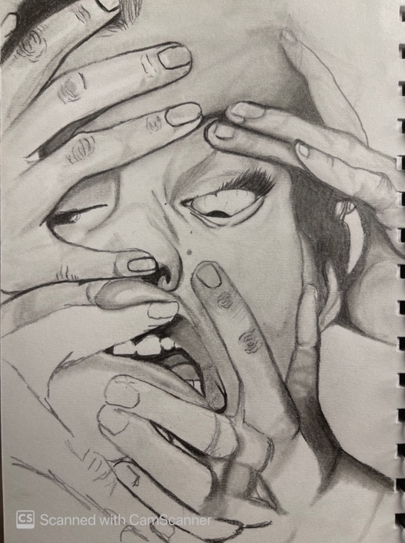

Zaha hadid’s buildings really inspired me with her artistic vision into creating more buildings and designs and I chose Cardiff university because it really fulfil all my architect needs and to learn the foundation of architecture. I think bringing what I will learn at Cardiff university to my home country will be such an honour. Growing up amongst many uniform, dull houses, I wasn't surrounded by architectural wonders; so, as a child whenever my parents took me out to cities like London, I would gaze up at the towering skyscrapers, archaic themed buildings and monuments both modern and antiquated. I was stunned. Of course, though back then they were nothing but pretty houses and tall, shiny towers to me. It's only recently that I discovered a passion for architecture. In developing my passion for architecture, I have found myself constantly growing my potential so that I can achieve the necessary requirements and experience. Since architecture is more environmentally conscious, I have worked towards understanding how building impacts the environment
and the necessary measures that can be undertaken to ensure minimal environmental impact.
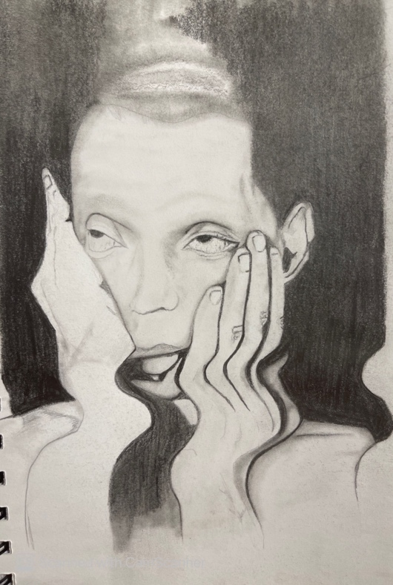
“wasted potential”

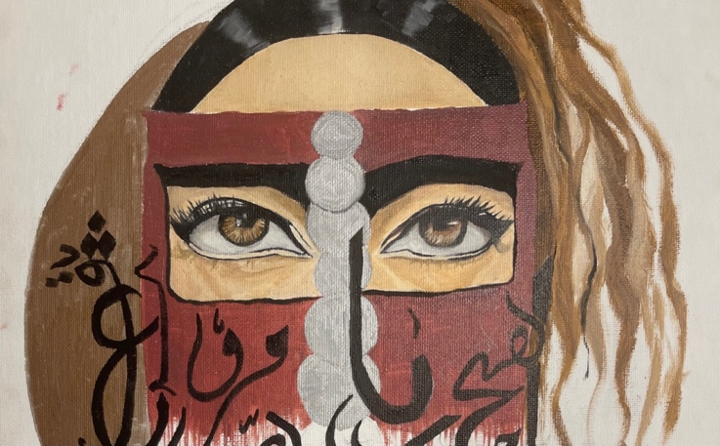
in this art piece it tells a story about how the Arab woman identity has been blurred through out the years but notanymore. and it tells the beauty and the stories thru their magnificent eyes which is what Arab women are
known for
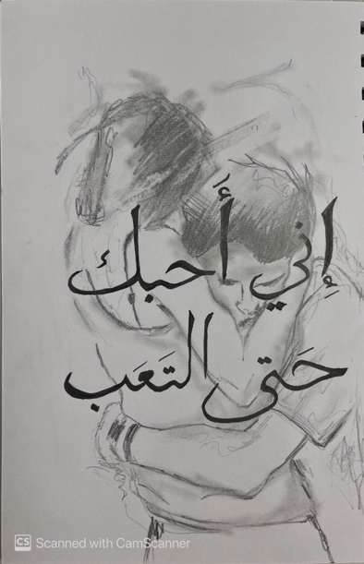

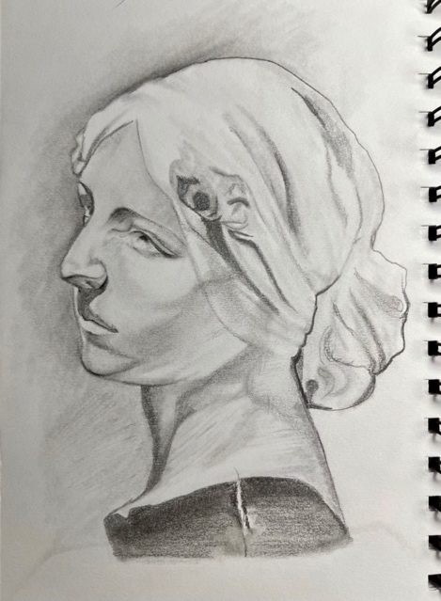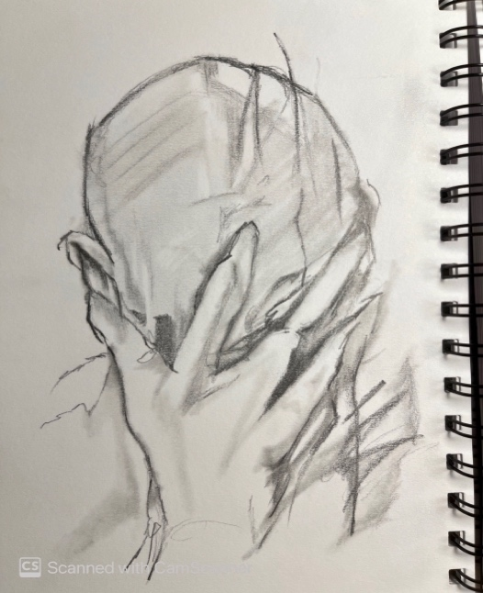

a sketch inspired by my favourite album called "blonde
by the artist frank ocean
and few random sketches

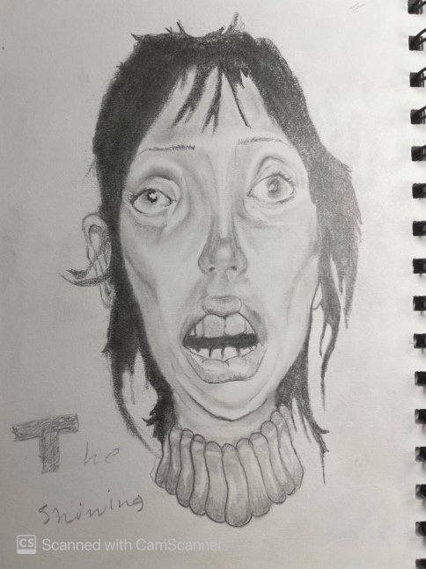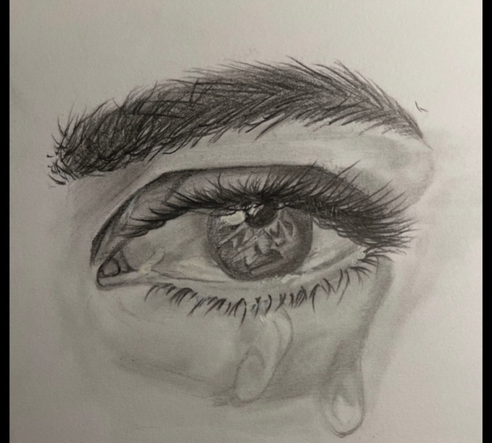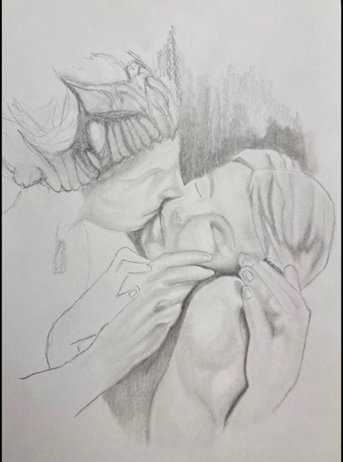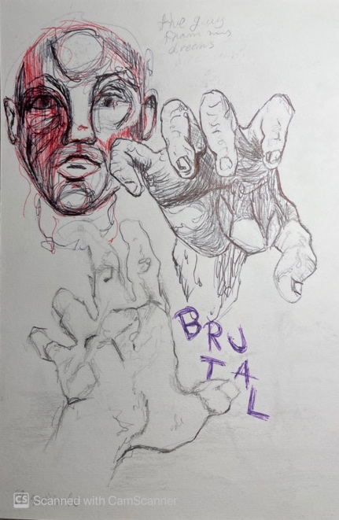

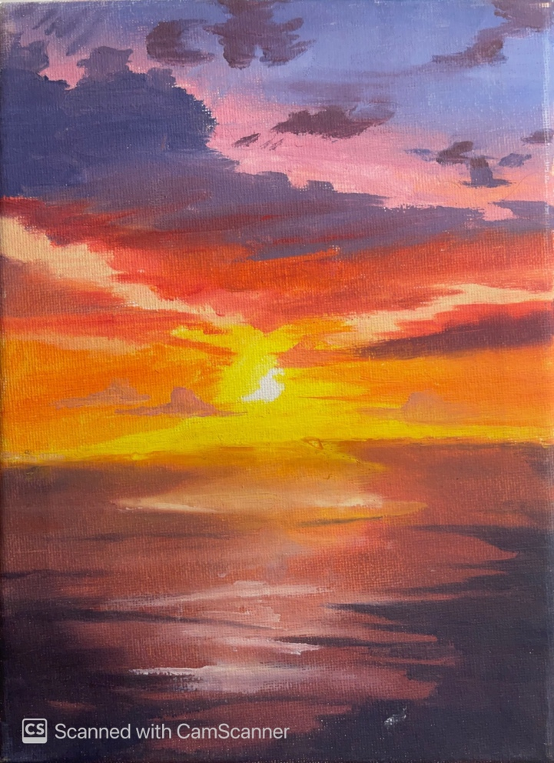
in preparing myself to fulfil the architecture requirement, I have constantly been upskilling my abilities alongside incorporating my talents to align with architectural works. Since the modern architecture industry emphasizes the use of computer-aided designs, I have already started to look into the basics of design software such as AutoCAD and SketchUp. I have done a prerequisite of the course elements and this has educated me on the various specializations in architecture. I have been able to improve my artistic and analytical skills by engaging in mini personal projects related to the design of buildings that accommodate agriculture and biodiversity. I have also been imagining the possible ways through which I can incorporate sustainability and accessibility into cities.
I am looking for opportunities that will offer me professional guidance alongside the opportunity to join a professional institution that will accredit me as a professional. Through the journey of pursuing my passion, I have gained the determination and commitment to undertake whatever it takes. Similarly, having a mentor has prepared me to collaborate with others towards contributing to the modern architecture industry competently.

