Vallipuram Navaratnam
Lecturer
College of Engineering and Science
Victoria University
Melbourne
Email: Valli.Navaratnam@vu.edu.au

19 April 2022

To whom it may concern

RE: Khalid Ahmed N Aljabry
I, Vallipuram Navaratnam, have known Mr. Khalid Ahmed N Aljabry for three years as a student in the Bachelor of Engineering course in Victoria university, Melbourne, Australia. I had the pleasure of teaching Khalid from his second year to final year of studies during this course.
I found Khalid to be a very keen student in his studies and achieving high grades is his units of studies. Few of the units during this course of studies required high level of research to complete the units. I found that Khalid had a high level of focused research skill and applying the research diligently in his work.
I believe Khalid has an interest in undertaking his learning in the field of engineering to the higher level and wish him well in his endeavor towards this interest.

Yours Truly
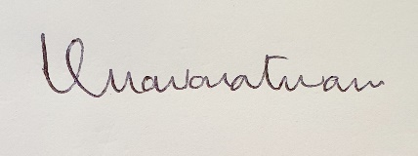
Vallipuram Navaratnam

