To whom it may concern

I had the pleasure of knowing YAZEED MAJED H HAWALAH in his high school years at Dome International Schools. He impressed me with his ability to be articulate about difficult concepts and texts, his sensitivity to the nuances within literature, and his passion for reading, writing, and he has my highest recommendation as a student.
He is talented at considering the subtleties within subject matters and the purpose behind school works. He produced an extraordinary research paper. He spoke clearly and eloquently about his ideas and responded to questions in a thoughtful way. Outside of the classroom, he is dedicated to help others. He is an insightful, sensitive, and deeply self-aware individual driven to explore art, writing, and a deeper understanding of the human condition.
Throughout the year he always supported his peers. His caring nature and personality allow him to work well with others in a team setting, as he always respects others' opinions even when they differ from his own. He also demonstrated his openness to and empathy for the opinions, feelings, and perspectives of others, along with shrewd powers of observation, all qualities that makes him outstanding as a student of Dome.
I am certain that he is going to continue to do great and creative things in his future. I highly recommend him for admission to your undergraduate program as he is talented, caring, intuitive, dedicated, and focused in his pursuits.
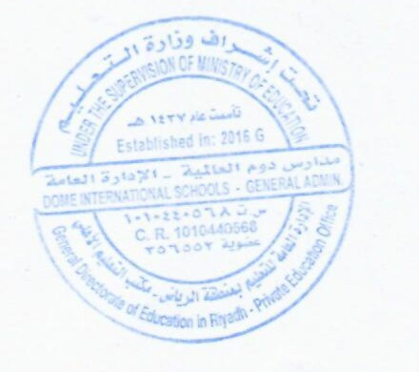
Sincerely,

Mr. Melkete Yohannes

