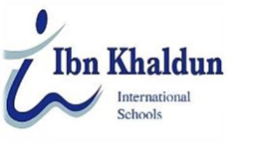
November 2023

Dear Dean of Admissions,
It is my great pleasure to recommend Wajd Abdullah Alzahrany for admission in the Engineering Departments. I got to know Wajd as her biology teacher at Ibn Khaldun International Schools. I am thoroughly impressed by her commitment to Aerospace Engineering .
I’ve seen from Wajd extraordinary intelligence and analyzing skills. Her project was on the level of a master student. She impressed me with her amazing analytical and challengeable skills.
In addition to her exceptional accomplishments in Biology as an undergraduate student, her cleverness and smartness made her an outstanding member of Ibn Khaldun International Schools. As a leader of her team apart of academic studying, she performed many brave situations displaying aforementioned personality trait.
In my opinion, I truly think that Wajd would be a tremendous addition to your university. She has my highest recommendation. Please feel free to contact me if you have any questions regarding her character or past academic work.
Sincerely,
Walaa Abdelmawla
Biology teacher at Ibn Khaldun International Schools
Walaa.abdelmawla@ikcedu.net

